Coercive Acts
(Intolerable Acts)
Information Sheet
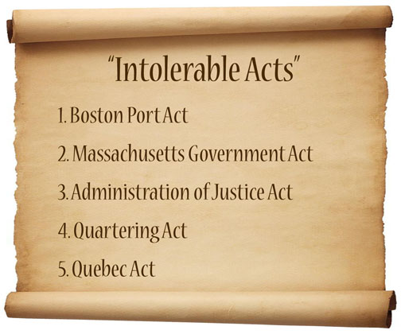
The Boston Tea Party made the British government furious. British Prime Minister Lord North convinced Parliament to pass laws called the Coercive Acts in the spring of 1774, which colonists called the Intolerable Acts because they were so harsh. These acts were an effort to make the colonists pay for the tea and to keep the colonists from planning other attacks.
These laws stopped all trade between Boston and Britain, did not allow town meetings, gave Britain control of the colony, and strengthened the Quartering Act. Since the port of Boston was closed, the trading of goods between the colonies also stopped which greatly impacted the economies of all the colonies. This led to support for Boston as goods were brought in from the other colonies. In addition it stirred revolutionary spirit throughout the colonies.

